1. **DESKRIPSI DATASET**

**Dataset** : zoo dataset

**Source** : <https://archive.ics.uci.edu/ml/datasets/Zoo>

**Attribute Information :**

1. animal name: Unique for each instance   
2. hair: Boolean   
3. feathers: Boolean   
4. eggs: Boolean   
5. milk: Boolean   
6. airborne: Boolean   
7. aquatic: Boolean   
8. predator: Boolean   
9. toothed: Boolean   
10. backbone: Boolean   
11. breathes: Boolean   
12. venomous: Boolean   
13. fins: Boolean   
14. legs: Numeric (set of values: {0,2,4,5,6,8})   
15. tail: Boolean   
16. domestic: Boolean   
17. catsize: Boolean   
18. type: Numeric (integer values in range [1,7])

1. **FLOWCHART**

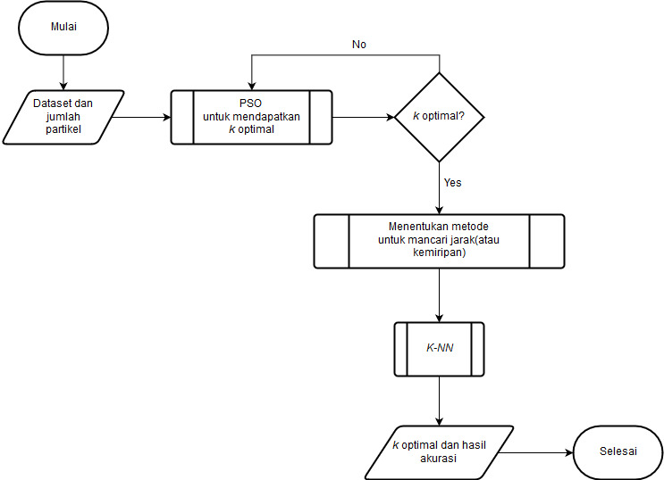

1. **MOCK UP**

* **Input**

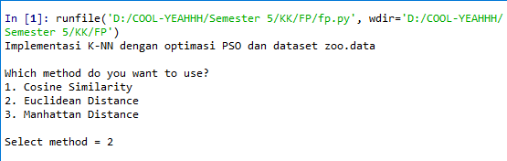

* **Output**

